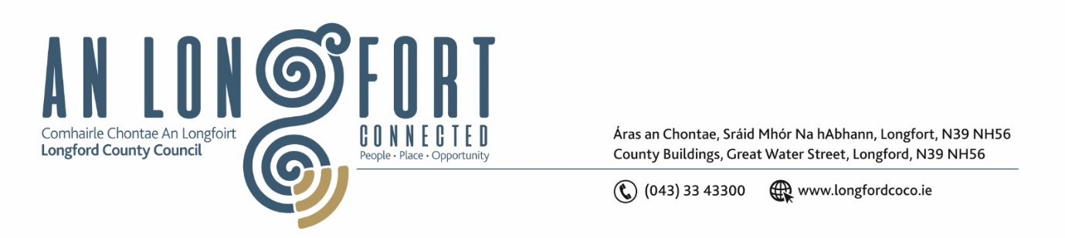

**GRANARD MUNICIPAL DISTRICT**

***Please note meeting will be held in Granard Library.***

**May 2024**

**To: Each Member of Granard Municipal District.**

**Dear Member,**

You are requested to attend a Meeting of Granard Municipal District to be held in Granard Library on **Tuesday May 2024 at 3.30pm** to transact business, as set out on the Agenda hereunder.

**Yours sincerely**,

______________________

**Claire McNabola,**

**Meetings Administrator**

**AGENDA**

Prayer before meeting.

**1.** Confirmation of Minutes as follows:

1. Granard Municipal District Meeting held on 26 March 2024 – enclosed.
2. Granard Municipal District Committee Meeting held on 26 March 2024 – enclosed.

**2.** Matters arising from Minutes.

**3.** Declaration of Interest by Members.

**4.** Management Report incorporating Area Engineer’s Progress Report – To Follow

**5**. Special Projects/Discretionary Grants 2024

**6.** Notice of Motions set out hereunder:

**Councillor Garry Murtagh**

1. I call on Granard Municipal District to seek funding for 2 Low-Cost Safety Schemes at:

* R198 intersected via Legga road, Junction (at Gerry Gorman's House)
* On the Aughnacliffe to Granard L-10451-0 road at Sonnagh Road L5089.

**Councillor Paraic Brady**

1. I call on Longford County Council as part of the realignment and traffic calming measures to make footpaths wheelchair accessible in the village of Drumlish.
2. I call on Longford County Council to seek funding for the construction of a footpath from the village of Ballinamuck to Ballinamuck graveyard.

**6**. Date of Next Meeting